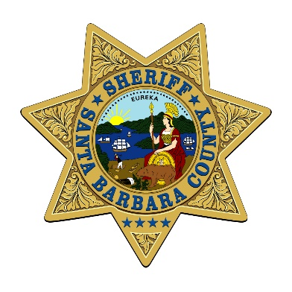 | SANTA BARBARA COUNTY SHERIFF’S DEPARTMENT  Civil Unit  312 E Cook St./P.O. Box 5049 1105 Santa Barbara St./P.O. Box 690  Santa Maria, CA. 93456 Santa Barbara, CA. 93102  (805)346-7430 Fax (805)346-7437 (805)568-2900 Fax (805)568-2909
ELECTRONIC* WRIT DECLARATION
*as defined in CCP 687.010(e) and 263.1(b)
Court Case Number: |  |  | County of Writ Issuance:
Judgment Creditor(s) |  |  | Judgment Debtor(s)
1. |  |  | 1.
2. |  |  | 2.
3. |  |  | 3.
4. |  |  | 4.

To the Sheriff of Santa Barbara County (hereinafter, the “Levying Officer”): THE ATTACHED WRIT OF
 | Execution: Total judgment amount (Line#11 on the writ) is $
 | Possession: |  |  |  | Sale |  |  |  |  | Attachment
 |  |  |  |  |  |  |  | Personal Property (describe):
 | Must match line 24(e) on Writ of Possession/Sale
 |  |  |  |  |  |  |  | Real Property (describe):
ISSUED on (date) , is either (check ONE only)
An original writ, or a copy of the original writ issued by the court as an electronic record, not already in the
possession of the Levying Officer
A copy of the original writ already in possession of the levying officer.
Levying Officer File Number:
This declaration is an attachment to instructions dated ____________________________
I declare, under penalty of perjury under the laws of the State of California, that the foregoing is true and correct.

_________________________________________________________________________________________________
(Type or print name) (Signature of Declarant)** (Date)
**Declarant must be the same party who has signed the instructions (i.e., the judgment creditor’s attorney or, if the judgment creditor has no attorney, the judgment creditor)

CCP 687.010 Rev 5/2018

