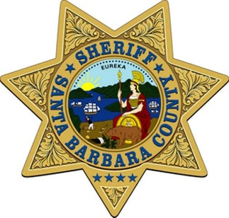
Santa Barbara County Sheriff’s Office

Raquel Zick |  | Date: 4/15/21
Public Information Officer |  | Time: 3:00 p.m.
(805)681-4192 |  | 21-049

News Release

Santa Barbara County Jail Awarded Accreditation from National Commission on Correctional Health Care

Santa Barbara, Calif. – The Santa Barbara County Sheriff’s Office has earned accreditation from the National Commission on Correctional Health Care by demonstrating compliance with NCCHC’s Standards for Health Services in Jails. Accreditation recognizes Santa Barbara County Sheriff’s Office dedication to compliance with the most respected standards in correctional health care.

The Santa Barbara County Jail underwent a rigorous on-site survey in September, 2020. An experienced physician and other experts in correctional health care surveyed the facility for compliance with standards on safety, personnel and training, health care services and support, patient care and treatment, health promotion, special needs and services, health records and legal issues.

Sheriff Brown said “This is a milestone in our efforts – along with Wellpath, our healthcare partner – to provide high quality health care to our inmates.”

NCCHC has surveyed and accredited jails, prisons and juvenile detention and confinement facilities for 40 years. The NCCHC standards used in accreditation are developed with input from the nation’s experts in correctional health care.

"In achieving NCCHC accreditation, the Santa Barbara County Sheriff’s Office has demonstrated its commitment to meeting constitutional requirements for health care delivery for incarcerated individuals,” said National Commission CEO Deborah Ross, CCHP. “Accreditation is a voluntary process and we commend the Santa Barbara County Sheriff’s Office for successfully undertaking this challenge to provide quality health care and instill confidence in the community it serves.”
###

